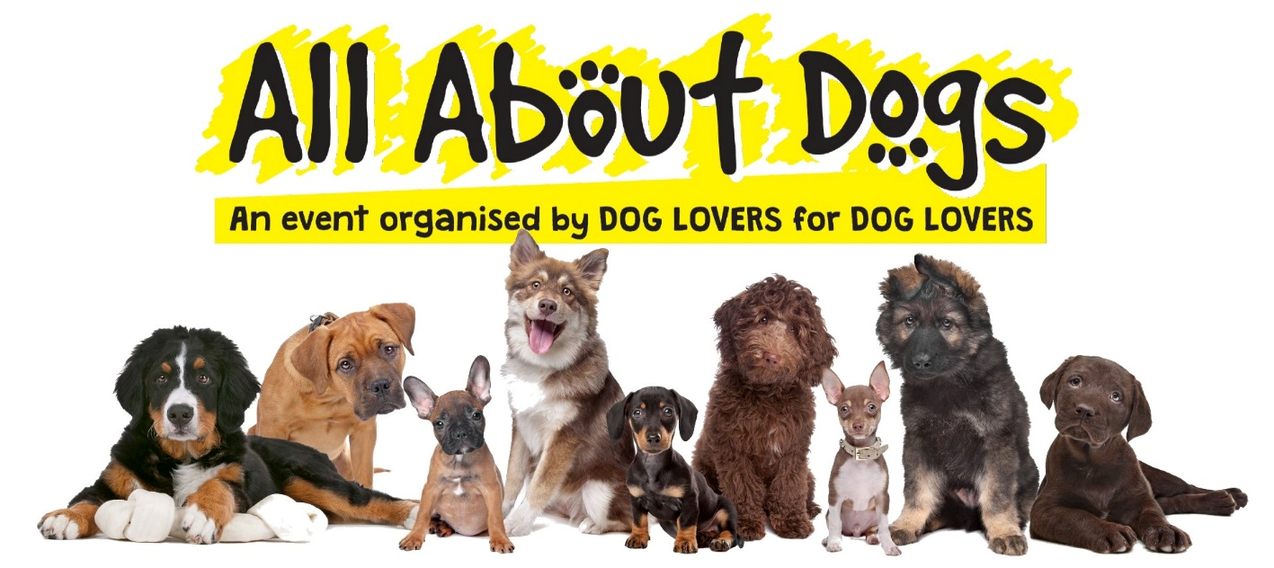

Exhibitors’ Information

Norfolk Showground – Dereham Road – New Costessey – Norfolk – NR5 0TT

Thank you for booking a stand for the Norfolk All About Dogs Show. The purpose of this paperwork is to ensure that you are provided with all the necessary information and to ensure that you are completely prepared prior to the show start date.

We want the show to be a huge success for your business and strongly recommend that you take some time (before the show) to explore the numerous marketing opportunities made available by taking part. You can find an exclusive discount code and artwork to share with your customers/followers on our website here.

Please read the following details carefully. If you have any queries, please contact us prior to the show. Aztec will not be held responsible for exhibitors that discover on the day of the show set-up that they have not booked enough space or are not happy with their booking details.

Full booking terms & conditions can be found online in the exhibitor section at the show website at www.allaboutdogsshow.co.uk

Sections:

- Set-Up & Breakdown times page 2
- Exhibitor Camping Info page 2
- Site Access page 3
- Health & Safety Measures page 3
- Insurance, Risk Assessment & Public Safety page 4
- Gazebos page 4
- Card Payment Machines & WIFI page 5
- Stand Space Booked & Exclusivity page 5
- Stall Presentation & Trading Standards page 6
- Waste Material & Rubbish page 6
- Contact Us & Venue Details page 7
- Directions page 7
IMPORTANT NOTES & CONDITIONS – PLEASE READ

SET UP & BREAKDOWN TIMES

SHOW OPEN TO PUBLIC Sunday 24th and Bank Holiday Monday 25th August 2025

9:30am – 5pm (both days)
SET UP

23/08/25 (Sat) |  | 11am – 5pm STRONGLY RECOMMENDED  PLEASE NOTE: Traders that arrive after 5pm will have to wait to 7am Saturday to be placed; Outdoor traders that arrive prior to 5pm can continue to set-up after this time.
24/08/25 (Sun) |  | 7am – 9am
25/08/25(Mon)  BREAKDOWN |  | 8:30am – 9am
25/08/25 (Sun) |  | From 5pm  PLEASE NOTE: No exhibitors are permitted to stay on site overnight on Monday 25th August.

Exhibitor Camping

- Exhibitor camping is permitted at the showground on the following nights only:
  - Saturday 23rd August 2025
  - Sunday 24th August 2025
  - NO CAMPING is permitted overnight on Monday 25th August 2025

- Power is not provided – generators are permitted between the hours of 8am-10pm

- BBQs are permitted, but must be raised off the grass

- Fresh water is available from standpipes situated around the site

Site Access

- Please report to security at the exhibitor entrance on arrival.

- The show is open to the public from 9:30am and closes at 5pm. If you are NOT on site and at your stall & ready by 9am on the first day of the show, for whatever reason, you may be refused entry, and no refund will be given. PLEASE NOTE – you will not be able to drive onto the site after 9am on each open day.

- Vehicle movement on the show area is strictly prohibited whilst the show is open to the public.

- Vehicle passes and wristbands to the show will be collected at the security gate on arrival.

- Only one vehicle pass will be issued per exhibitor, please contact us prior to the show if you require more - a maximum of two additional passes will be issued free of charge.

- Vehicle Passes must be placed on your dashboard, for easy viewing at all times.

- Exhibitors must keep to the set-up and breakdown times.

Health & Safety Measures

- Despite the lifting of COVID restrictions, the following rules have been established for the safety of all exhibitors, visitors and show staff – it is important that they are adhered to. If you are unsure of the latest government guidelines CLICK HERE for full details on the government’s website
- Please do not attend show if you feel unwell – in this case the organiser is under no obligation to refund any of the pitch fee (or additional costs) paid
- Traders are expected to keep their stall safe and clean – the organisers have the right to refrain a trader from operating if it is felt that the stall is unsafe
- Sneeze guards are required for food products (if applicable)
- Traders should always have a copy of their stall risk assessment and public liability insurance to hand at any time

Insurance, Risk Assessment & Public Safety

- All exhibitors must have present at the event a copy of their own public liability insurance (minimum £5 million cover), business insurance and any other relevant licences (including alcohol).
- Risk Assessments – all exhibitors should complete a risk assessment for their stall. We require exhibitors to have their risk assessment with them at the show and available if requested. PLEASE NOTE – if you have not already completed a risk assessment, you can download a template at https://www.aztecevents.co.uk/exhibitor-downloads/

- Exhibitors are responsible for their stand, including every object displayed on their stand and liability of all claims arising from handling of objects. You must not place goods or tables of any kind in public walkways. Vehicles, boxes or trolleys must not be moved on site whilst the show is open to the public. Exhibitors must not pack away until after the published closing time as stated by Aztec.

- Exhibitors are permitted to leave their goods overnight at the show at their own risk.

- Exhibitors shall indemnify Aztec against all claims, damages or expenses arising from any incident, that may occur at the show.

- No unauthorised vehicle movement is permitted on site whilst the show is open to the public.

Gazebos

- Exhibitors are provided space only and must bring their own gazebos/marquees - Aztec Shows LLP DO NOT provide any gazebos/marquees.

- IMPORTANT SAFTEY NOTICE: Please ensure that your gazebo / marquees are suitable for outdoor use, are securely pinned (or weighted) and can withstand strong winds if necessary.

- Aztec Shows LLP accept no responsibility for any damages or injury caused by any stallholder gazebo which breaks, collapses or is damaged by the weather.

Card Payment Machines & WIFI

- There are no cash dispensers on site

- WIFI is not provided at this venue

- Please check that your card payment device (PDQ) can take payments using local 4G/5G networks or your phone signal. Always check with your provider.

- Please check with your provider for network coverage. The following links are signal checkers for popular providers:
  - EE https://ee.co.uk/help/mobile-coverage-checker
  - Vodaphone https://www.vodafone.co.uk/network/status-checker
  - O2 https://www.o2.co.uk/coveragechecker
  - 3 https://www.three.co.uk/support/network-and-coverage/coverage

- Aztec Shows LLP accept no liability for any issues (including a drop in signal strength) with mobile networks that may result in card transactions failing. We always recommend having a backup method of accepting payments.

Stand Space Booked & Exclusivity

- Location – all spaces are allocated prior to the event – you will be met by an Aztec representative and shown to your space on arrival. Please do not begin to set-up until you are shown to your allocated space.

- Please ensure that you have booked adequate space for your stand – you will be allocated the space size that you have booked. This space includes access to the stand and (if applicable) storage of vehicles.
E.g. If you have booked a 3m x 6m space, this means that you have booked a 3m frontage, by 6m depth.
- Goods or tables that are outside the booked space will be requested to be removed. Chairs are NOT supplied. If you are unable to fit vehicles on the space booked, you will be required to park in the public car park or exhibitor camping area.

- Exhibitors are only permitted to display & sell items detailed on the booking form (unless authorised by Aztec PRIOR to the show). Aztec has the right to ask unauthorised products to be removed.

- We do not guarantee exclusivity to any exhibitor.

Stall Presentation & Trading Standards Regulations

- Aztec reserve the right to ask exhibitors to remove goods considered unsuitable or not listed at the time of booking.
- All stalls must be presented to ‘high’ (and professional) standards as expected at a quality event.

- To comply with Trading Standard regulations, all exhibitors must ensure that all goods are clearly priced.

Waste Material & Rubbish

- All rubbish must be placed in skips provided or taken away by the relevant exhibitor – cardboard boxes must be flattened prior to placing in the skips.
- Exhibitor rubbish must not be placed in the public bins.
- At the end of the event, stand space must be left clear. Please do not pile rubbish on your stand or beside bins – take it with you OR throw in the skip provided.

Contact & Venue Details

Venue Address: |  | Norfolk Showground – Dereham Road, New Costessey, Norfolk, NR5 0TT
Exhibitor Site Contact:  (during event only) |  | Steve Upson / Matt Upson
Email: |  | info@aztecevents.co.uk
Aztec Office Number: |  | 01702 549623 (open Mon-Fri 9am -5pm)
Emergency Contact:  Map: |  | 07583 074669 or 07905 173657
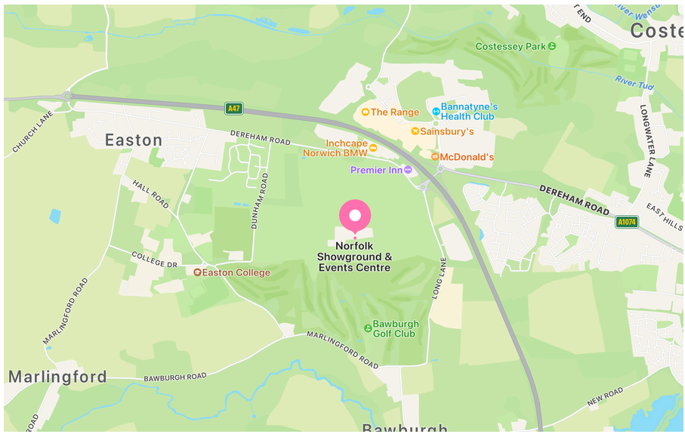

Directions:

Postcode for Sat Nav: NR5 OTT
From the North and West – easily situated just off the A47 Norwich Southern Bypass at the A1074 Longwater Interchange.
From the South and East – Travelling to Norwich via the A11 from London any beyond or A140 from Ipswich, take the A47 westbound and follow the signs for Norfolk Showground.

